**CPEC Highway Network**

~By Agha Muqarib, Mansoor Ahmed, Saad Ali & Waleed Sohail~

**INTRODUCTION**

As the CPEC is the newest project not much connecting stuff is known about it so its details are shared through this project. The aim is to spread the networking knowledge of CPEC among concerned and public.

CPEC is China Pakistan Economic Corridor which is under construction. CPEC is the framework of regional connectivity. This represent the connection between the cities through highways.

**NODES AND EDGES**

Thee nodes are the points in a graph depending upon its nature. In this case the nodes or vertices are all the cities or towns or villages that fall in the route of highway network. A total of 40 nodes is obtained from the data as per provided by CPEC official website which means 40 cities are covered in highway network of CPEC.

Edge is the path between two connected vertices. In this case, the edges are the path or route from one city to another city. There were 44 edges in total that means that there are 44 routes of going without repeating the same path again.

**NETWORK CONSTRUCTION**

The network was constructed through simple code in graph by plotting all the edges in a specific manner and then letting the framework read it to form the network and make a graph between all the vertices. All the information is extracted from the network and graph formed on the framework through code.

**Data Collection**

We collected our data from the official site of government of Pakistan. We collected the data of the highway route between different cities in which cities our nodes and the path through they are connected is edge in our project there are 41 nodes and 82 edges different visualizations have been achieved through data i.e. average degree, maximum degree, minimum degree, degree distribution etc.

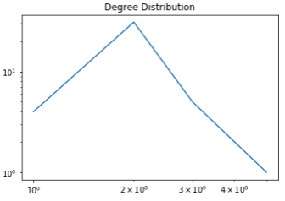

**DEGREE DISTRIBUTION**

The degree distribution (or neighbor distribution) Is the probability that a randomly chosen node has connections (or neighbors). In this case, the probability that one randomly chosen city in the network had had different connected cities!

**CLUSTERING**

If clustering is higher, then the closeness between nodes is higher and vice versa which means that the steps required to reach from one node to another node depends on coefficient of clustering which is found to be 0.33.

**DIAMETER**

The shortest path to reach from one end (first city) to another (last city) is called diameter which is found to be 2

|  |  |  |
| --- | --- | --- |
| Average degree | Max degree | Min degree |
| 2.2 | 5 | 1 |

**Figure 1 Degree Distribution**

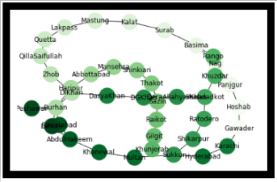

**DEGREES**

* Max degree shows that there is a city which is connected to 5 other cities.
* Min degree shows that there is a city which is connected to just one city
* Average degree shows the connection of all nodes which means that one city on average is connected to 2 other cities.

**Figure 2 Edges and Nodes**